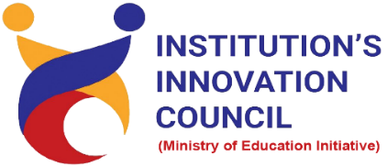
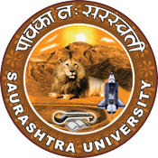
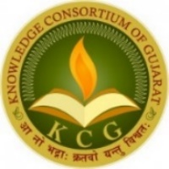

Collective Foundation

Robotics Master Training and Certificate Program Course Under KCG
13th June 2022 to 23rd June 2022
At
Department of Computer Science & Department of Electronic
Saurashtra University Campus, Rajkot
Contents
Saurashtra University – IIC 2
Brief about Event 2
Key Points 14
Outcome 14
About the Speaker/Chief Guest 15
Connect Us: 16

Saurashtra University – IIC
The university is dedicated to instruction, research, and extending knowledge to the public (public service). Ministry of Education (MoE), Govt. of India has established ‘MoE’s Innovation Cell (MIC)’ to systematically foster the culture of Innovation among all Higher Education Institutions (HEIs). The primary mandate of MIC is to encourage, inspire and nurture young students by supporting them to work with new ideas and transform them into prototypes while they are informative years. Saurashtra University is one the Organization that have constituted the IIC to foster the vision of MoE and be a part for the promotion and development of innovation ecosystem.

Brief about Event

- Day 1:

- 3D Printing & 3D Designing:
On that day, first we had done the registration of the participants. After that we had started the Inauguration function. In this function, Dr. Ranjan Khunt, President of IIC, Dr. Harikrishna Parikh Sir Co-ordinator – Innovation Club and Mr. Parth Sejpal CEO of SU Start-up and Entrepreneurship Council, Incubation Centre were present. Our eminent Speaker was Ms. Subha Mehta.
Topic of the first day was 3D Printing and 3D Designing using by 3D pen. Student had learned a lot about how to use 3D pen and by using of 3D pen we can make various 3D printed designs like car, butterfly, square and many more.
In afternoon session, we made designs using Tinker cad Application. Using Tinker cad application, we could create objects. Learners had seen the process of how to make Keychain.
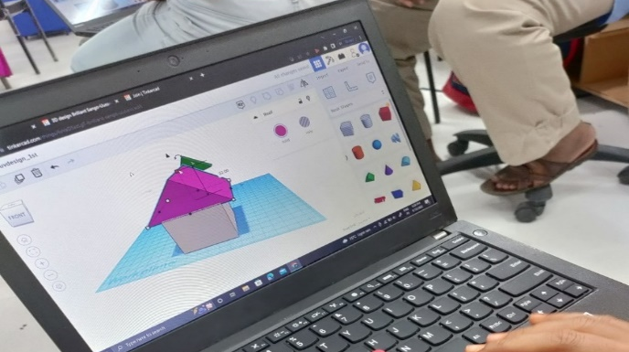
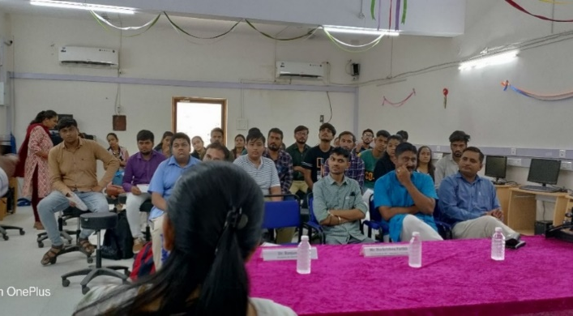
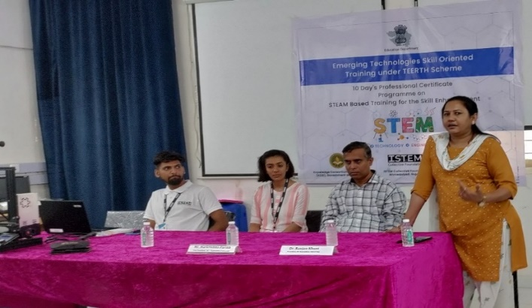
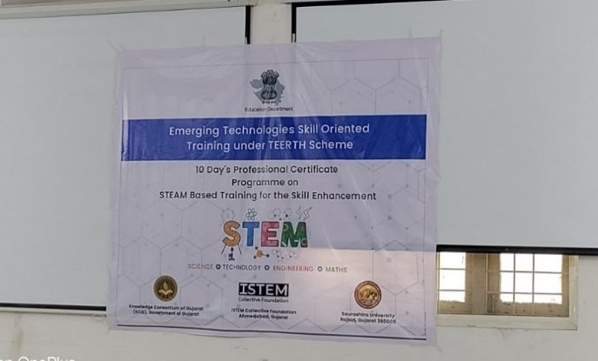

- Day 2:

- Introduction about Blockzie, Game design, Story with motion, video sensing project
On the 2nd day, introduction of Blockzie application.
Topics Covered
- What is coding?
- Computational thinking to solve problem.
- Use of Editing tools
- What is algorithm?
By using Blockzie web application students learned about animations, like say hi to people, bird fly in the sky, walking man etc. Also, learned how to develop food collection game. In all the activities coding was required and all the activities controlled by coding understood by the speaker. Flage, look, sensing, sound, event, motion, math functions were used by user for made animation and Game.
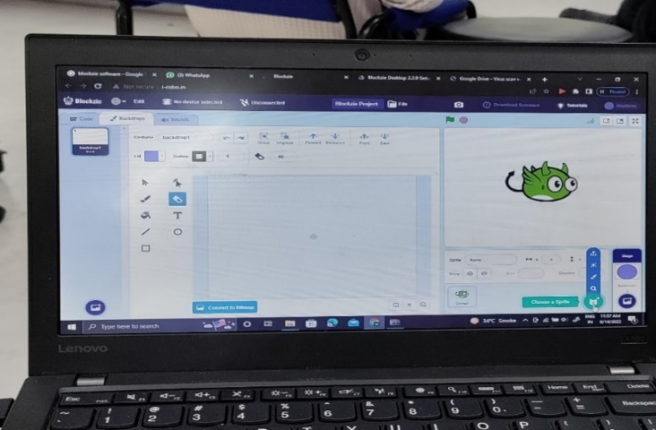

- Day 3:

- Introduction about MIT APP, Home Automation app, advance feature of MIT APP

MIT APP Inventor:
Students learned about how to developed application by using MIT App. This application is freely available. We can create code by using MIT App and output will be display in mobile. There were many activities done by this application.
Like,
- by click on button message “Hi!! Codies” will be displayed on our Mobile screen.
- Add background image with sound.
- Bouncing Ball (Ball rotate on screen as per user instruction)
- Create Doodle (create name using touch)
- Clear Screen
All the above activities also worked based on code.
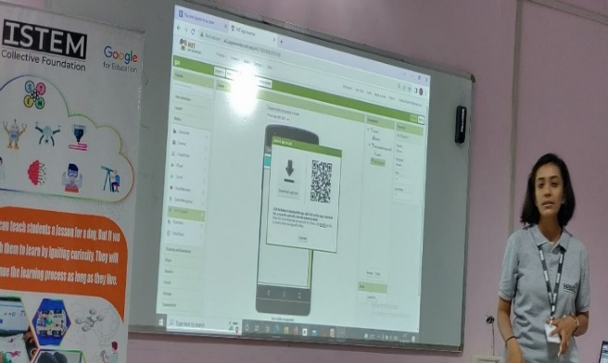
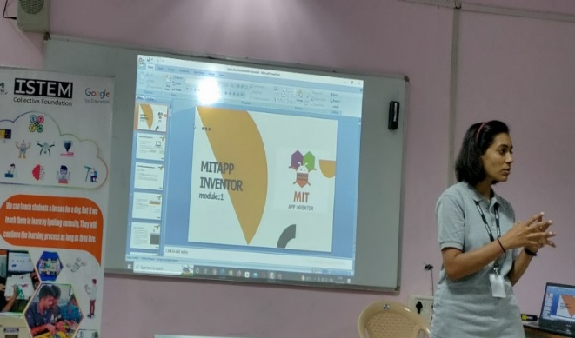

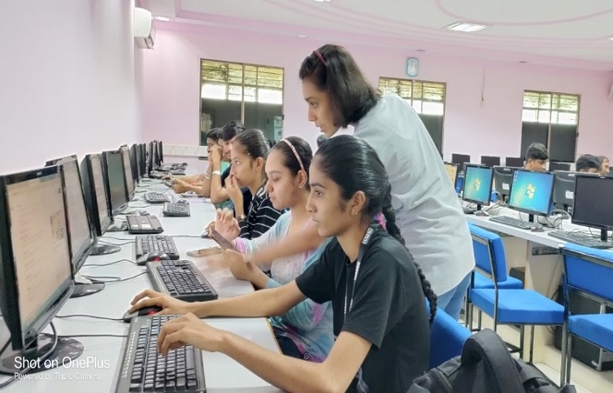

- Day 4:

- Basics of Electronics, circuit Design, Practical of Electronics

Student Learned about what is the Difference Between Electronics & Electricals. Components like PC, Mobile, Fan all the Electronics Products made up with IC that is electronics and Knowledge of Controlling device that is electricals. Also, Learned about Voltage, types of Current, Circuit Connection, Register, Multi-meter, types of Transistors, Sensor, Breadboard, Wire Connection etc.
Many practical activities were done by students.
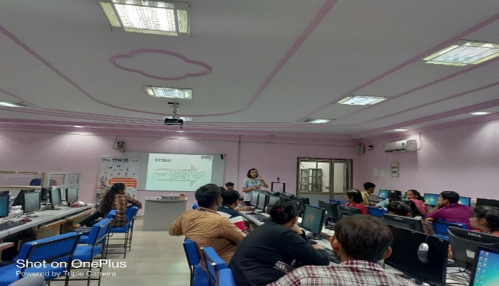
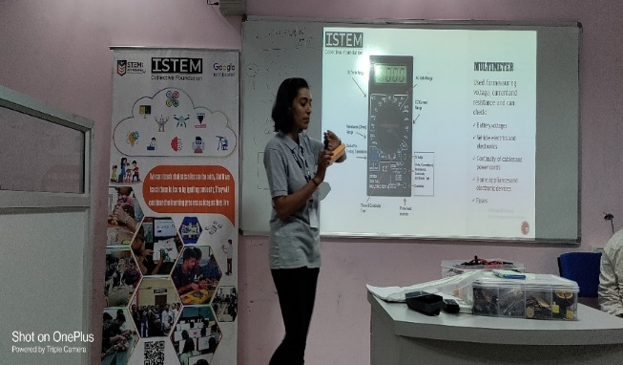
LED on/off using register, LED on/off using push button, LED on/off brightness controlled by potential meter.
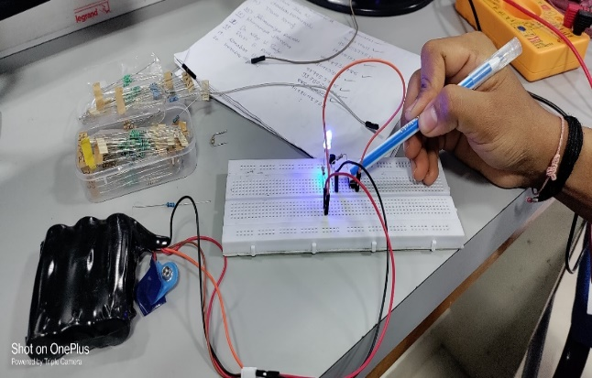
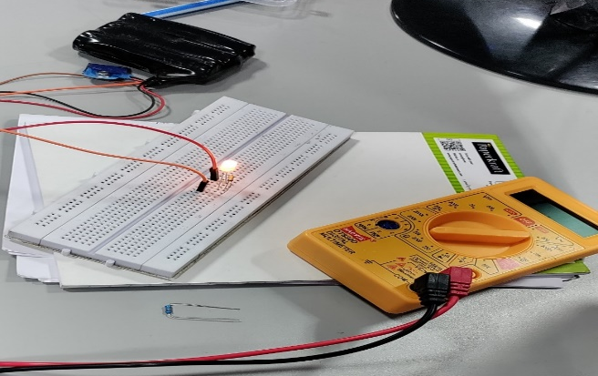

- Day 5:

- Introduction of Arduino & IDE, Basic of Arduino Project, Real world of Arduino

Arduino consists of both a physical programmable circuit board and a piece of software or IDE (Integrated Development Environment) that runs on your computer. Students learned about how to write and upload computer code to the physical board. Arduino UNO is a microcontroller. Using Arduino board user can perform many activities.
Like, LED starting using Arduino, LED starting in series using Arduino, Blinking of LED in series using Arduino, Arduino program in Tinker cad etc.

Code installation in Arduino Board
- Select UNO Board.
- Select port- com3.
- Write code in setup () & Loop ().
- Digital write & Digital read methods are used in program.
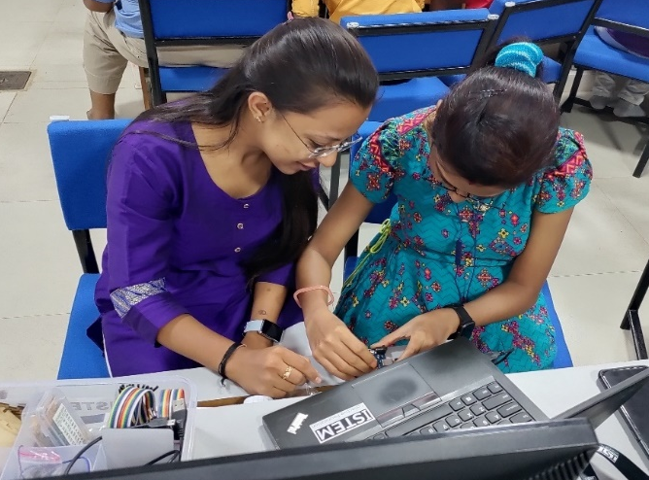
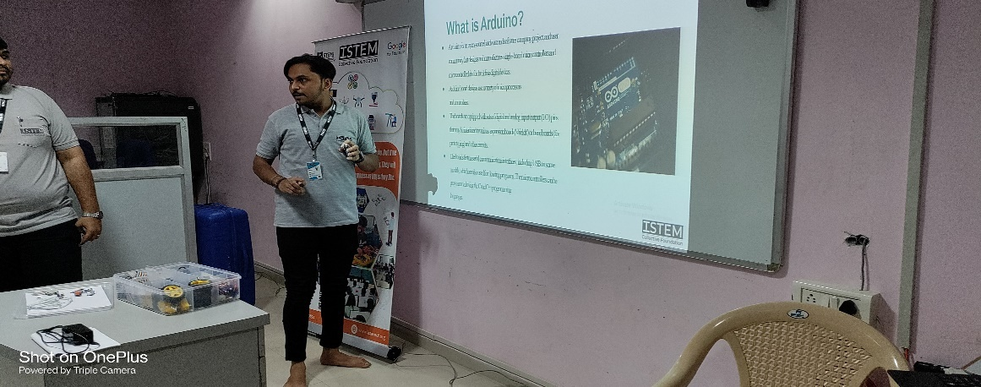

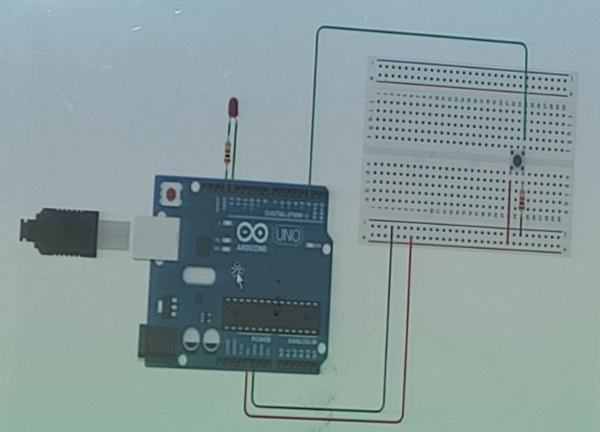

- Day 6:

- Introduction of NodeMcu, IOT, Advanced Agriculture Automation, Gps based project

Students learned about NodeMCU that is a low-cost IOT Circuit. Which can connect objects and data transfer while using the Wi-Fi and hotspot function.
IOT that is internet of things, in this feature all the things are connected to internet (cloud). Benefits of IOT is work can be done without manpower so, we can save the time. Few disadvantages of IOT are security & privacy and cost is high.
Students had done the programming of blinking LED using NodeMCU and WIFI password configuration.
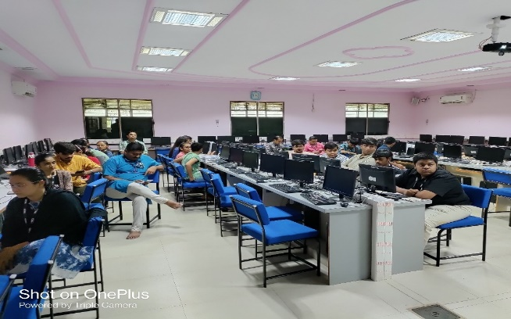
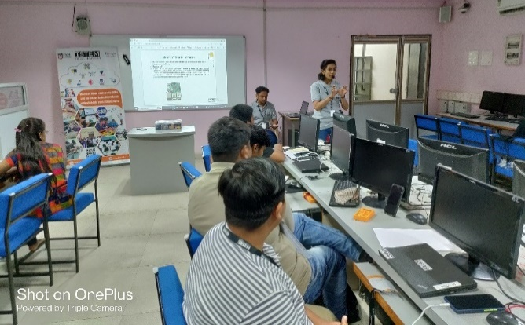
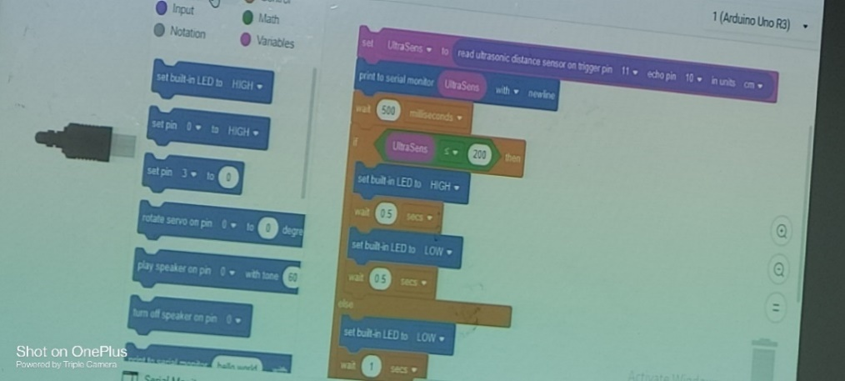

- Day 7:

- Design a Humanoid Robot, Design a RC car, Practical of Robot & RC car

Students learned about types of Remote-Control car.
There are many types of RC car
1)Wired car using DPDT switch
2)Wireless car using WIFI
3)Wireless car using Bluetooth
4)Wireless car using RF module
Students got the depth knowledge about wireless car by using Bluetooth. Servo motor, chassis, Battery, wheels, Jumper wire, Bluetooth module, Arduino UNO components were used for the RC car. Car controlled by Application.
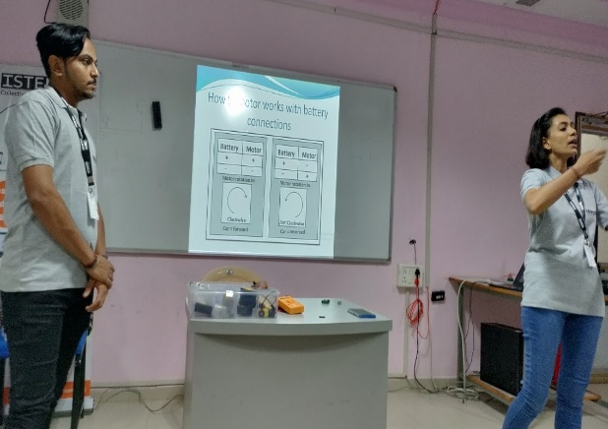
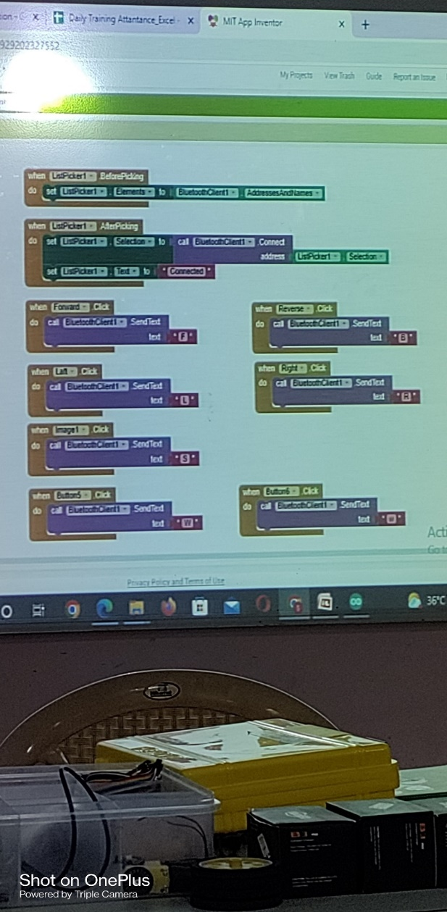

- Day 8:

- Fundamental Concept of Python, Programming of pyramid and Calc

Students learned about basic functions of Python by using of Python language. Generally, use of these language in the game development, artificial intelligence, web development, virtual assistant software application etc. Also, students had done installation of Python and programming in Python.
Print any statements, print stored value in variable, print addition of two values, checking value is greater and Programming of pyramid & Calc was made understood by the speaker.

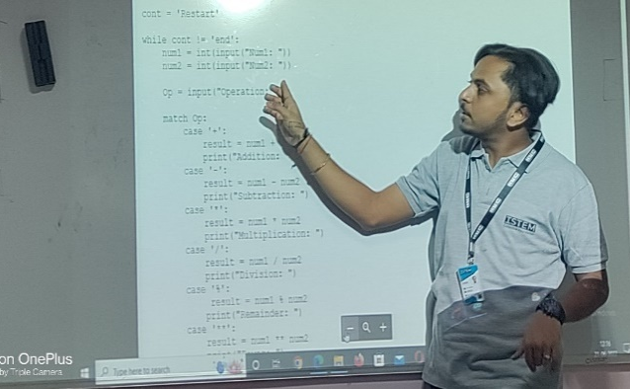
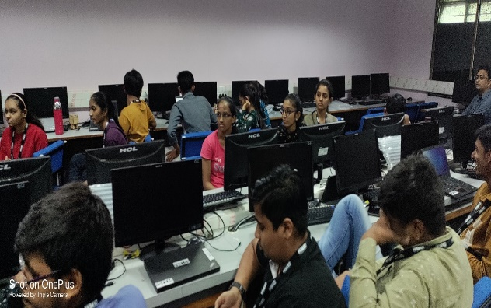
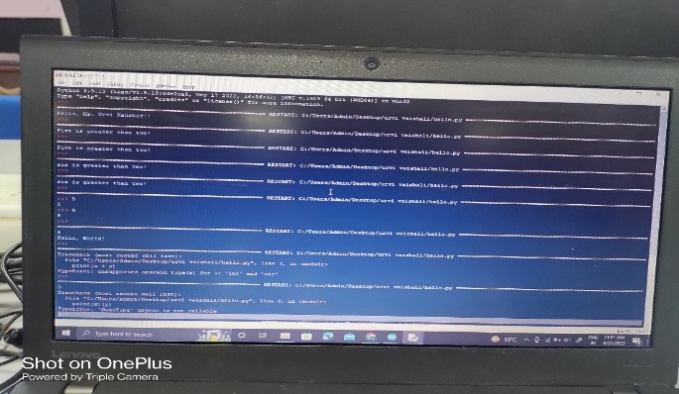
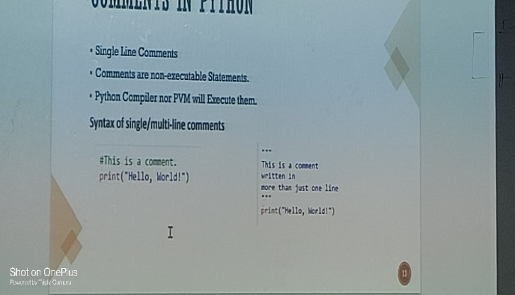

- Day 9:

- How to Design a Drone, Drone flying practice

Students learned about theorical concept of Drone and which places drones are use. Like, Drone used in agriculture, forest, urban development, disaster management etc. student had done the practical use of drone. For the control of Drone, Blockzie software developed logic of flying. if touch the edges then blast was made understood by the speaker.

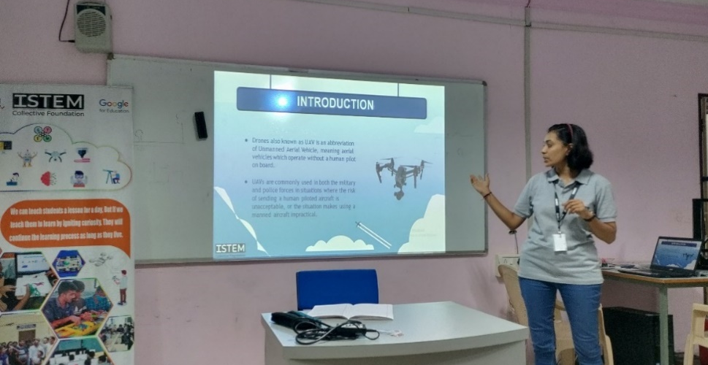

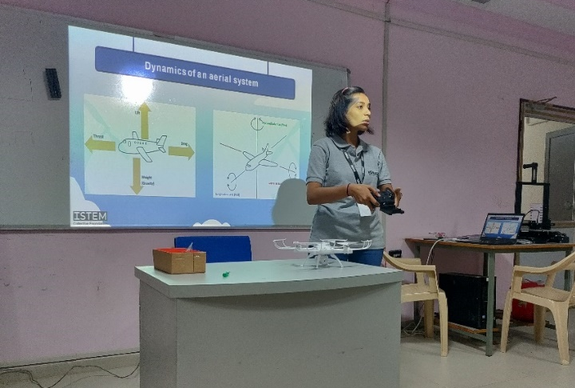
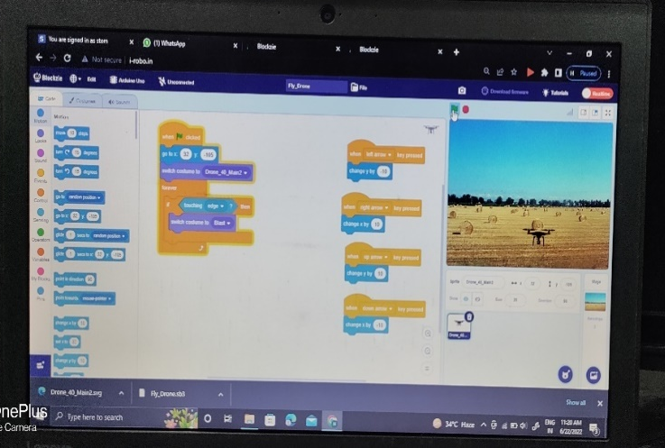

- Day 10:

- Certification distribution, Project exhibition & Valedictory Function

On the last day we had organised valedictory function and distributes certificates to the participants who attend these 10 days’ Workshop. Dr. Harikrishna Parikh Sir, Mr. Parth Sejpal CEO Of Incubation Centre and Co Ordinator of ISTEM Mr. Krunal Desai was Present.
In this function students had explained their project to the audience. Faculties and students had shared their reviews related to these 10 days training program.

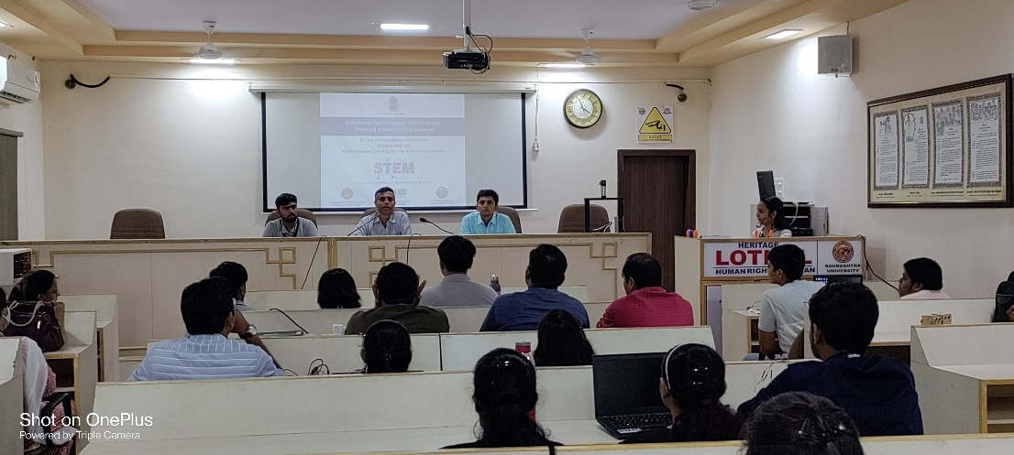

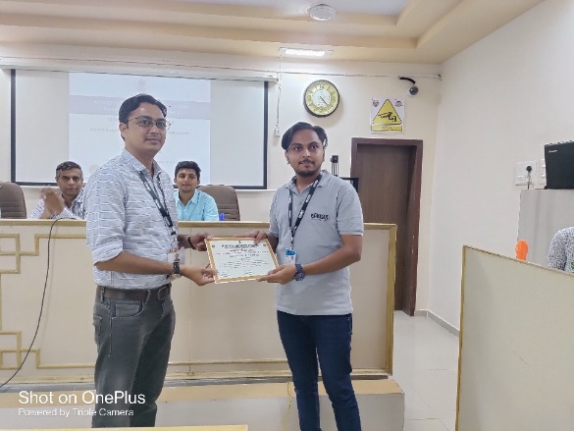

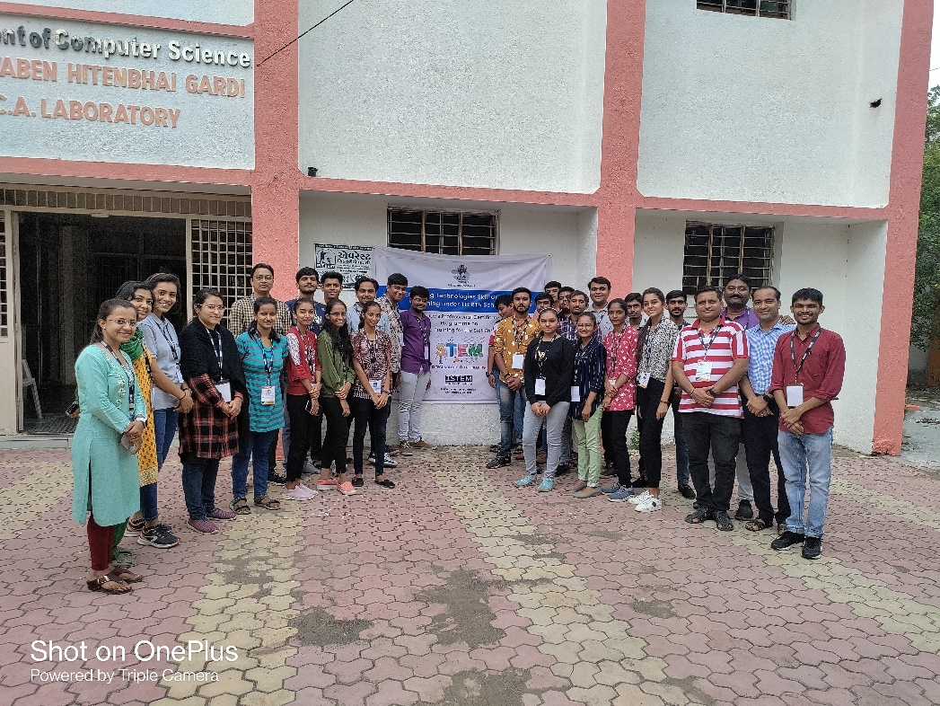

Key Points

During These Ten Days Session, below mentioned points were discussed:
- Design Thinking
- Basics of Electronics
- 3D printing and 3D Designing
- Algorithm And Flowchart
- Sensor and Actuators
- Mechanical Power Tool
- Arduino & IOT Device
- Block Coding
- Drone Flying

Outcome

As per the event, various types of kits and ideation was understood by the trainer. Students learn a lot about various types of software’s and applications and how to use kits as per resources, how to solves problems with various examples. Robotics Training Program will be helpful to students to embark their skills.

About the Speaker/Chief Guest

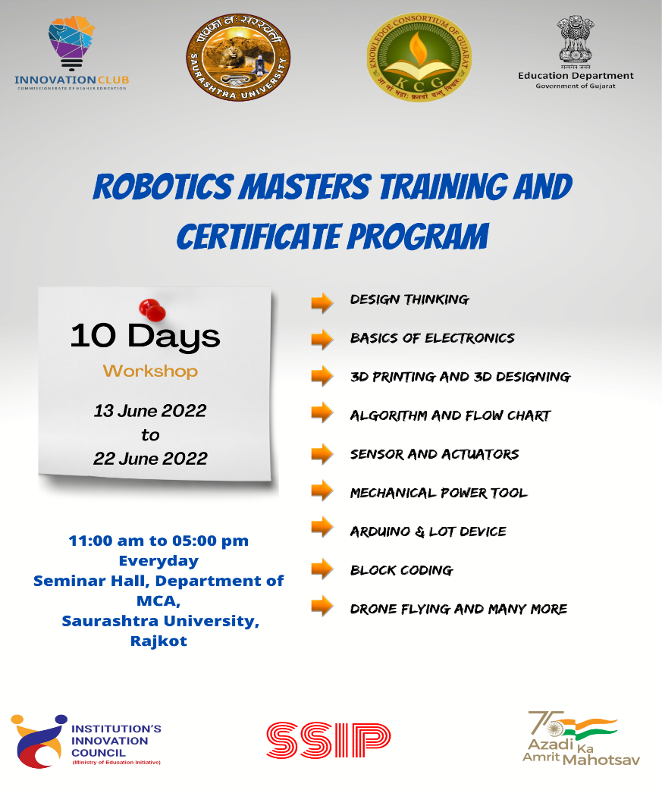

Connect Us:

https://www.linkedin.com/company/susec iic@sauuni.ac.in
https://www.facebook.com/iicsauuni bit.ly/SU-SSIP Location
https://www.instagram.com/susecrajkot https://bit.ly/SUSEC-youtube

